#1

CLEANING AND HYDROCARBON RECOVERY IN STORAGE TANKS

Hector Cruz, Engineer

Jan 2019

#2

Types of Cleaning

* Mechanical Cleaning
* Automated Mechanical Physical Cleaning
* Physical Chemical Cleaning
* Automated Physical Chemical Cleaning
  + Online Cleaning
  + Out of Operation Cleaning

#3

Types of Cleaning

Mechanical Cleaning

* Mechanical extraction and disposal of mud.
  + 0% hydrocarbon recovery
  + Tanks are offline for an excessive period of time
  + 0% return on investment for refinery
  + Unsafe environment
  + Hydrocarbon spillage
  + Obsolete and costly process

#4

Automated Mechanical Physical Cleaning

* Mud extraction using robots
  + High costs and robots are unable to reach to all internal sections of the tank
  + Necessity of maintenance personnel to physically enter the tank
  + 0% hydrocarbon recovery
  + 0% return on investment

#5

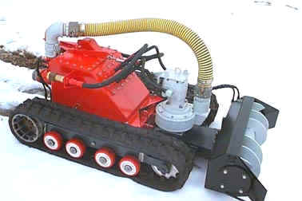

#6

Chemical Cleaning with Hydrocarbon Recovery

* Online Cleaning
  + This type of cleaning is done with the tank in operation, utilizing the TumTank™ for Process Equipment system, separating in-line the hydrocarbon, water, and sediment from existing sludge, gradually monitoring sediment quantity at the bottom, forming a water interface at the bottom of the tank.
  + This type of cleaning is recommended for tank maintenance so as to return clean tanks back into operation.

#7

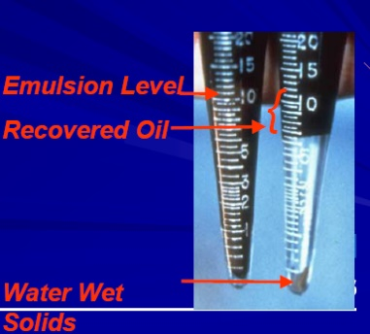Online Cleaning is done in two ways:

* Continuous injection type (3 – 10 ppm of chemical product) for a minimum of 3 months
* Batch type (30 – 100 ppm) for a minimum of 5-10 injections

#8

Out of Operation Cleaning

* When tank is out of operation due to high mud content and/or maintenance.
  + The following test must be done to verify hydrocarbon recovery feasibility
    - Age of mud
    - Quantity of mud (sludge)
    - Volume and distribution of mud in tanks (Thermographic 3D images, profiling)
    - Laboratory cleaning simulation
    - Determination of existing % of hydrocarbon, % of water, and % of sediments
    - Hydrocarbon quality

#9

Volumetric Profiling and Mud (Sludge) Composition

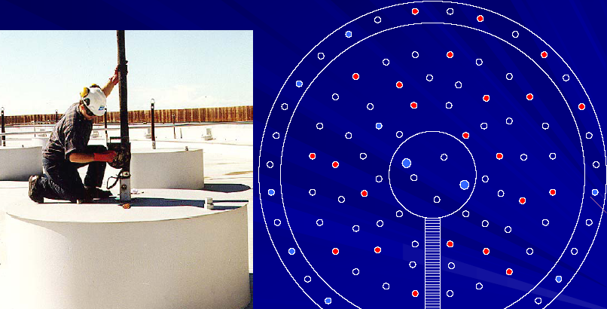

REQUIRED SAMPLES ARE TAKEN WITH STRATIFIER EQUIPMENT

#10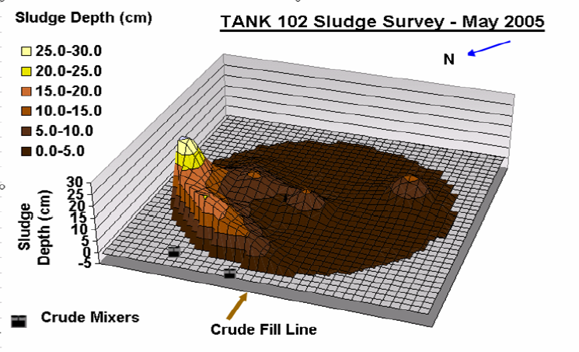

According to the data collected and thermographic images, three-dimensional volumetry of sludge is determined

#11

Laboratory Simulation and Determination of % of HC, % of Water, and % of Sediment

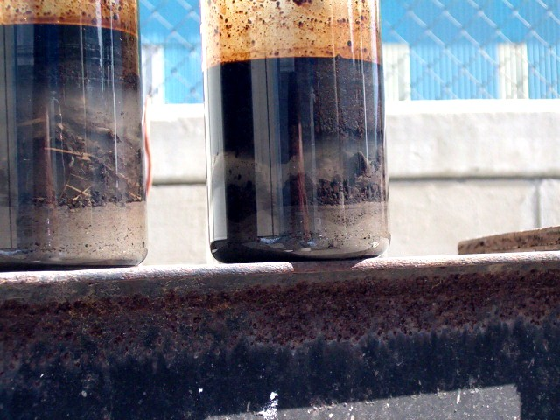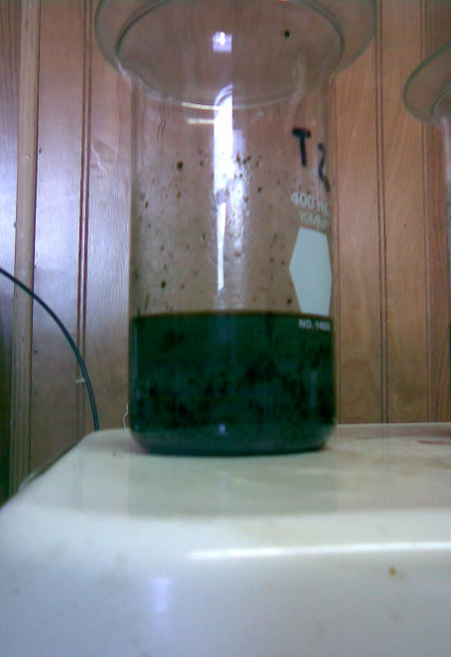

Mud Sample Mud separated as hydrocarbon, water, and sediment

#12

BASIC CLEANING PROCEDURE

* After having quantified the amount and distribution of the mud (sludge)
  + Conduct a tank survey, to verify inputs and outputs, drains, service vapor, water, electricity, accessibility, etc.
  + Service distance and quality
  + Distribution of lines between tanks

#13

BASIC PROCEDURE

* Once the study has been carried out, along with the DTI of the provisional installation, the circulation and heating of the system will proceed, as follows.

#14



#15

* Progressively we will monitor, keep a record, and new temperature profiling from the interfaces inside the tank to follow the progress of sludge separation, with the help of the infrared vision and specialized software.

#16

Temperature Profiling from different tank heights

#17



#18



#19



#20



#21



#22



#23



#24



#25



#26



#27

COMPARISON VS. MECHANICAL CLEANING

MECHANICAL

* 0% Hydrocarbons recovery
* 2 – 8 months execution time
* Approximately cost from $9MM - $15MM pesos

BASIC CLEANING

* 80% - 95% Hydrocarbon recovery
* 0.5 – 2 months execution time
* Approximate cost $11 MM pesos
* High investment returns
* 5 – 20% sludge in solid disposition with low quantities of hydrocarbon and water